**How to run YOLOV7 on an image locally.**

**Windows 10/11 CPU/GPU:**

**Prerequisites:**

* Anaconda
* Python (pip)
* **Create a conda environment.**
  + conda create venv
  + conda activate venv
* **Clone the YOLOV7 repository from GitHub.**
  + git clone <https://github.com/WongKinYiu/yolov7.git>
  + change directory to this cloned repository.
* **Install the necessary packages from the requirements.txt file.**
* pip install -r requirements.txt
* **Do these steps if you want to execute in GPU,**
* Install CUDA from <https://developer.nvidia.com/cuda-downloads>.
* If the installed CUDA version is 11.x, install pytorch using following command : pip install torch==1.11.0+cu113 torchvision==0.12.0+cu113 torchaudio==0.11.0 --extra-index-url <https://download.pytorch.org/whl/cu113>
* If CUDA version is different, check with <https://pytorch.org/get-started/locally/> to install compatible version of PyTorch.
* In GPU mode, quantization of weights happens from FP32 to FP16. Hence, sometimes the model returns no predictions. So, We should specify not to perform quantization. Change Line #31 in detect.py file in the cloned repository to : half = False
* **Run the command**

python detect.py --weights yolov7.pt --conf 0.25 --img-size 640 --source inference/images/horses.jpg

* This will run the YOLOV7 on the default test image provided in the repository.

* The command when run with the tag “--device 0” will run it on GPU and when run with the tag “--device cpu” will run on CPU. The default value of --device is 0.
  + python detect.py --weights yolov7.pt --conf 0.25 --img-size 640 --source --device cpu inference/images/horses.jpg
* The result of the detection will be stored in yolov7\runs\detect\exp.

Fig: runs/detect/exp/horses.jpg.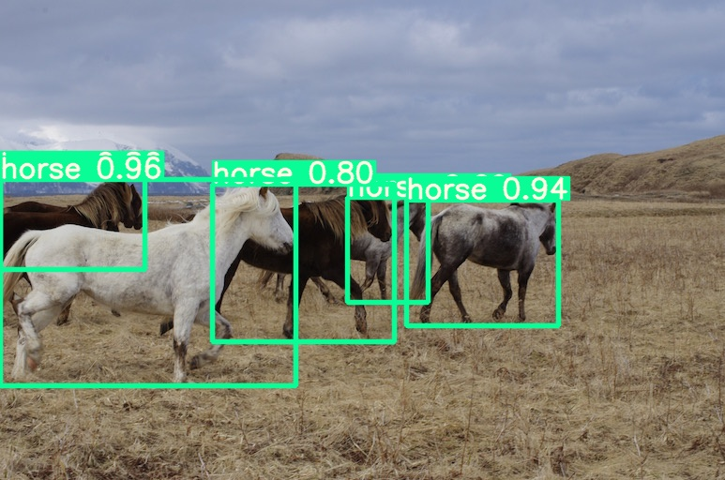

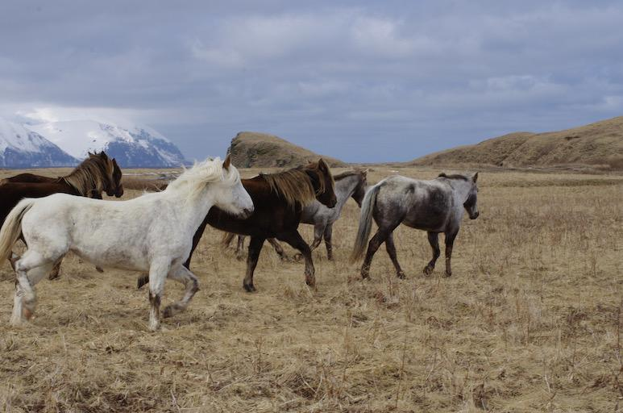

Fig: inference/images/horses.jpg